Welcome to WATERSCOPE,
BDM’s Online Customer Portal

GETTING STARTED

Those BDM Rural Water System customers with a cellular meter installed at their hookup now have the ability to go online and monitor their water usage. If you have one of these meters, you are no longer required to send in monthly meter readings, but monitoring your usage for leaks is still important and your responsibility. As with the traditional customer-read meters, all water that flows through the meter is the customer’s responsibility, regardless if it was a leak or not. The following is a how-to guide for using the Waterscope Customer Portal.

Your water readings are recorded in 5-minute increments, and once a day those readings are transmitted through the cellular network and posted to your Waterscope account. Please be aware that the usage shown is always 24 hours behind.

To gain access to the online portal, you will need to contact the BDM office with your email address. Please send an email to markh@bdmruralwater.com or call the office at 605-448-5417. After we create your account, you will receive an email with your user name and password. Please note, this email will come from WATERSCOPE, not BDM. Check your spam folder if you are having trouble receiving the email. The email will contain a link that will bring you to your account. (You may change your password at any time after the first log-in, if you wish). From then on, you can go to www.waterscope.us to log in to your account.

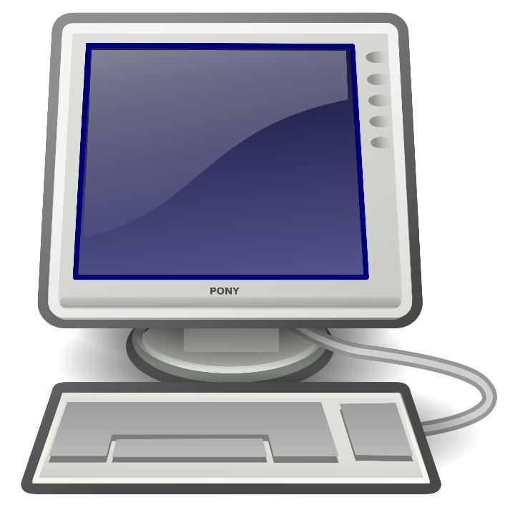

USING WATERSCOPE

Once you are logged in to your account, you will see the following “OVERVIEW” screen:

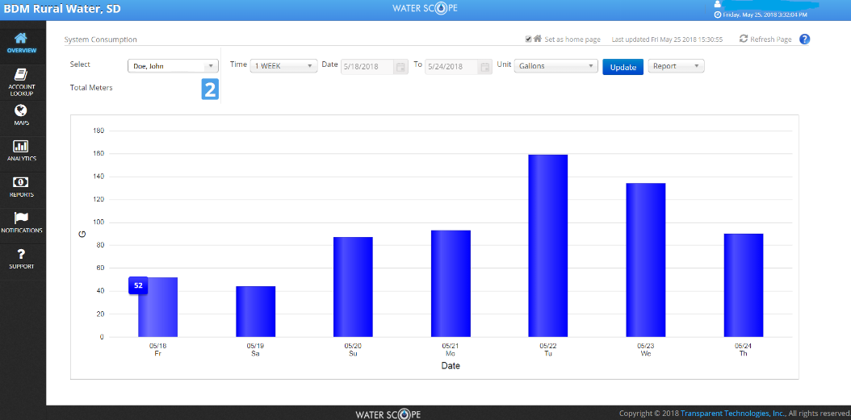

This customer owns two hookups, and the total usages for both are displayed on the graph on this page. By hovering your mouse over one of the columns, you will see the total usage for both meters on that day.

By clicking on “ACCOUNT LOOKUP” at the far left of the screen, you will bring up the following:

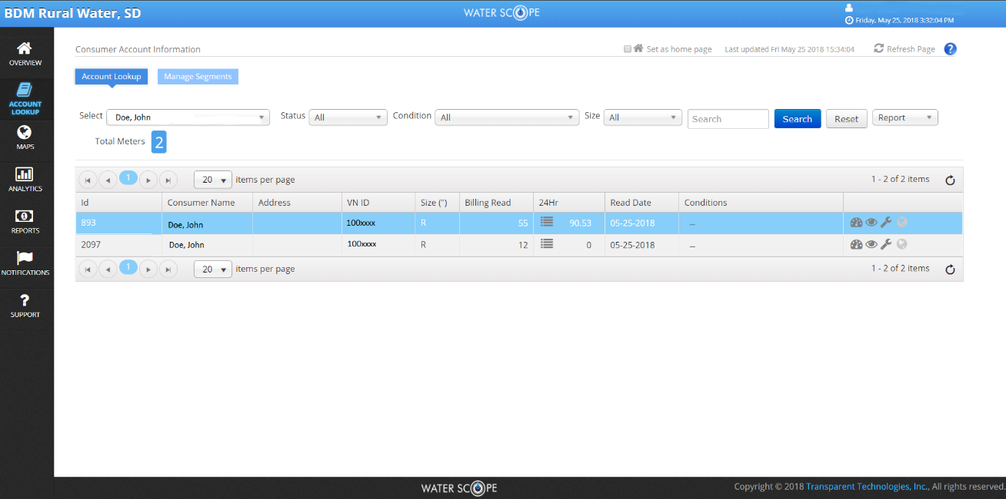

This screen will list all the hookups in your group. To pull up an individual hookup’s
information, click on the Dashboard symbol at the right of the screen for that hookup.

To familiarize yourself with the Portal, click on “DASHBOARD” at the far upper left of the new screen:

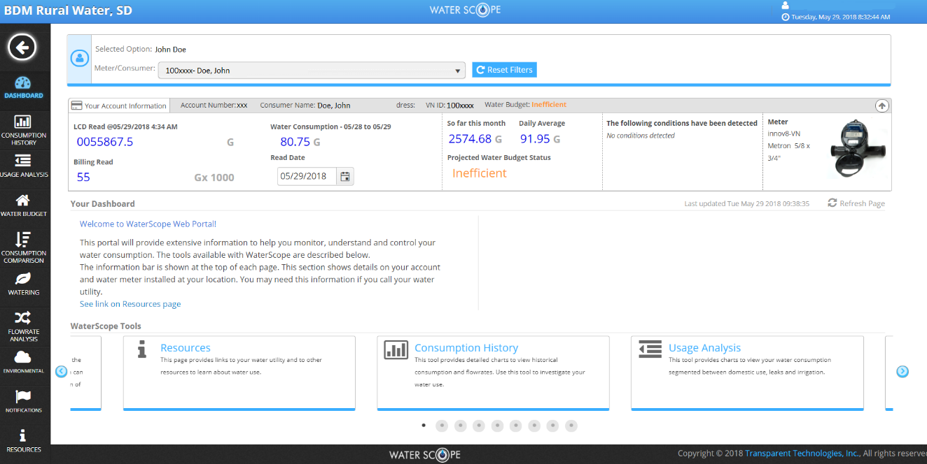

By reading the information on this screen, you will better understand some of the features of the
Customer Portal.

On the left side of the screen you will find the following menu:

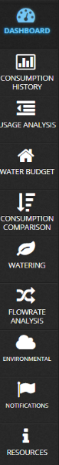
Consumption Comparison displays the usage from the current month with the usage from the same month last year.

Watering is not applicable, as BDM does not have any watering restrictions at this time.

Flowrate Analysis is a detailed view and breakdown based on the GPM provided via the 5-minute interval data.

The Environmental screen allows you to monitor the daily high & low temperature from the meter.

Notifications gives you the ability to set your notification parameters & circumstances.

Resources contains a list of informational websites related to general water use.

The Dashboard is the Customer Portal landing page. It contains utility messages and alerts.

Consumption History allows you to view detailed GPM and interval totals.

Usage Analysis shows detailed breakdown of the usage for the selected meter.

Water Budget allows the customer to view how close they are to their targeted usage.

Click on “CONSUMPTION HISTORY” on the left of the screen to continue to the hookup’s information screen:

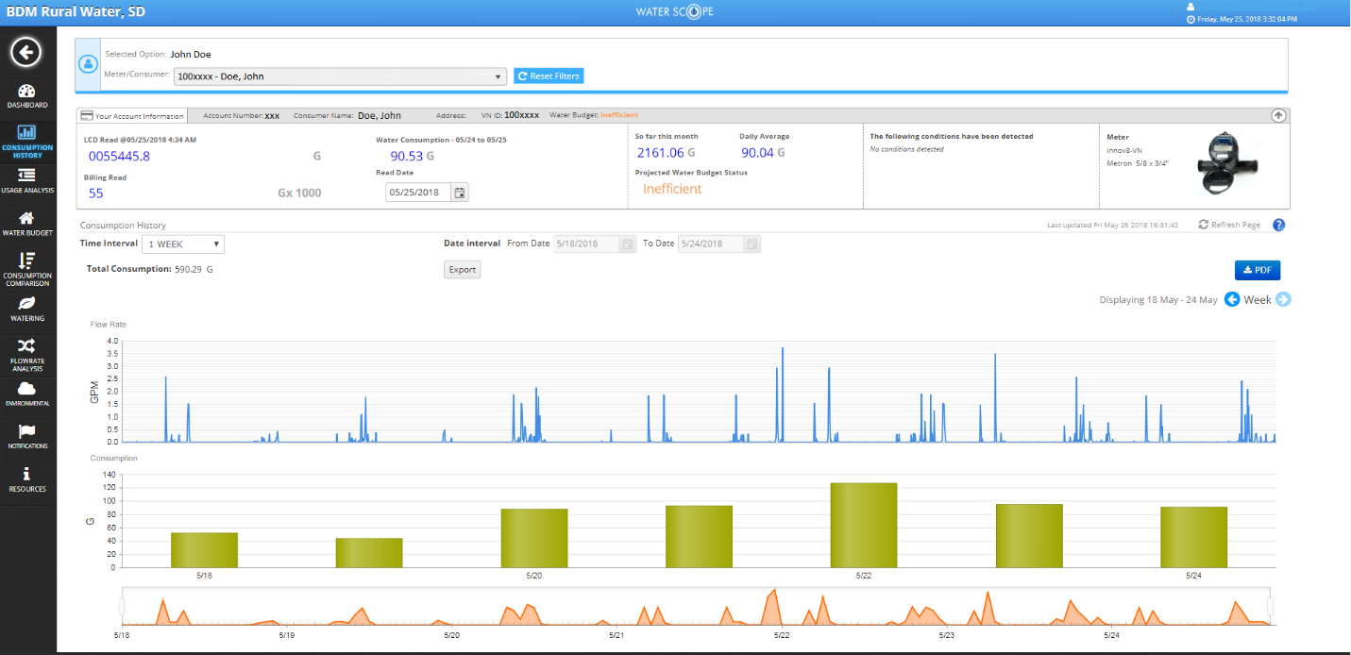

This screen will show detailed information for your hookup. The blue graph shows flow rate in gallons per minute. The green bar graph shows total gallons used per day. Hover your mouse over the graphs for exact amounts. You can change the Time Interval to show one day, one week, one month, or a custom time frame. You can also use your mouse’s wheel to change the graph to show hourly usage by hovering over the graph area and scrolling the wheel.

Your Water Budget may show your usage as “Efficient, On Target, Inefficient, or Wasteful”. The account above is labeled “Inefficient” due to the usage of a power washer a couple weeks earlier in the month. These labels are preset by Waterscope, so even if your account shows “Inefficient” or “Wasteful”, this may be normal for you depending on your own unique situation. For example, if you are watering cattle with BDM water, or you are watering lawns or trees, Waterscope may label your usage “Wasteful”, so don’t be alarmed necessarily by this categorization alone.

The blue flow rate graph is the best indicator of a leak. If the blue lines do not return to the zero baseline, you may have a leak. The following screen is an example of a leak from a cattle waterer:

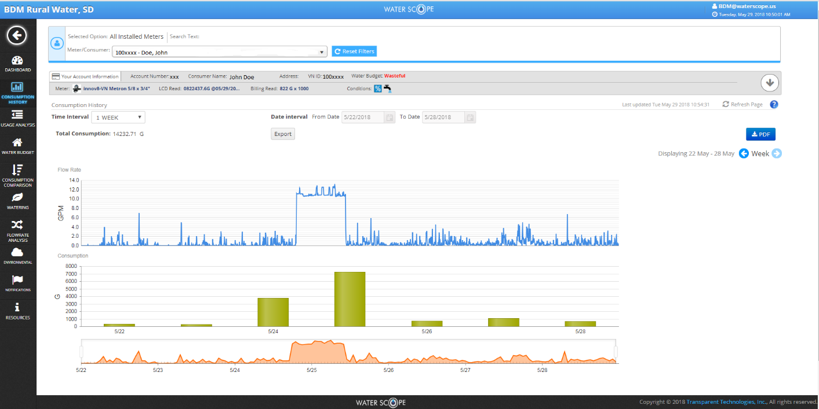

NOTIFICATIONS

Waterscope provides notifications for many different situations that may arise. Some commonly seen notifications are:

Leak The flag for a leak will trigger should a meter run constantly for 24 consecutive hours. If the Waterscope program recognizes one 5-minute interval with zero consumption, a new 24-hour monitoring cycle is started.

Intermittent Leak This flag is designed to identify situations such as toilet leaks. It looks at an intermittent, continuous flow between two flow rates over a specified time period.

High Usage: The high usage alarm allows you to monitor high consumption on a daily basis. If a meter exceeds the high usage limit in any 24-hour period, the flag will be triggered.
Unexpected Use: You can set a time period to receive notifications if any water is being used during that period. For example, if you are going on vacation, you can tell Waterscope to notify you if there is any water usage while you are gone.
You can customize the Online Portal to send leak, high usage, and other notifications via email. To set these notifications, click on “NOTIFICATIONS” from the menu on the left side of the screen. Select the items you want to be notified on, and enter your email address.

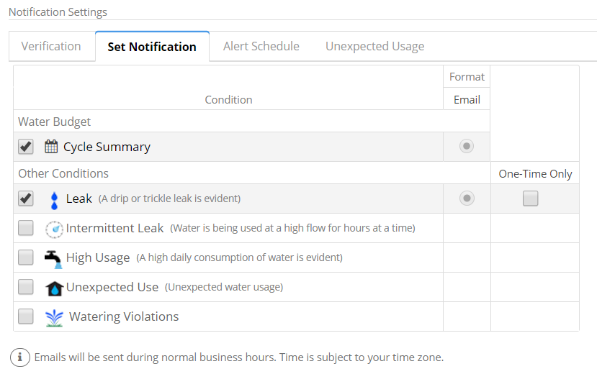

For additional help using the Customer Portal, many screens have a question mark symbol
near the top right corner. By clicking on the question mark, a pop-up box will appear with helpful
information pertaining to that screen:

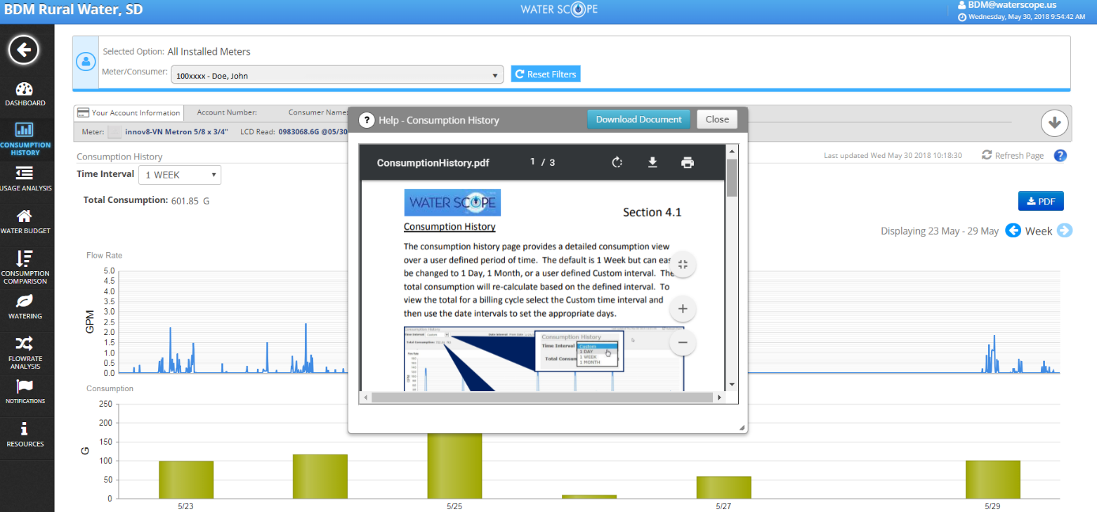

The information in the pop-up box can be downloaded and saved or printed, if you wish.

SMARTPHONE & TABLET USERS

Waterscope offers a free app for both Apple and Android devices. Search “Waterscope” in the Apple Store or on GooglePlay. At this time the app is only available for those users with one hookup. It will not work if you have multiple hookups.

Please be aware that Waterscope will periodically update and make changes to its Customer Portal that may not be reflected by the information contained in this guide.

We hope that Waterscope will provide our customers with a useful tool for managing their water consumption. If you encounter any problems or have any questions while navigating the Waterscope Customer Portal, please feel free to call the BDM office at 605-448-5417.

This institution is an equal opportunity provider.
Esta institucion es un proveedor de servicios con igualdad de oportunidades.

